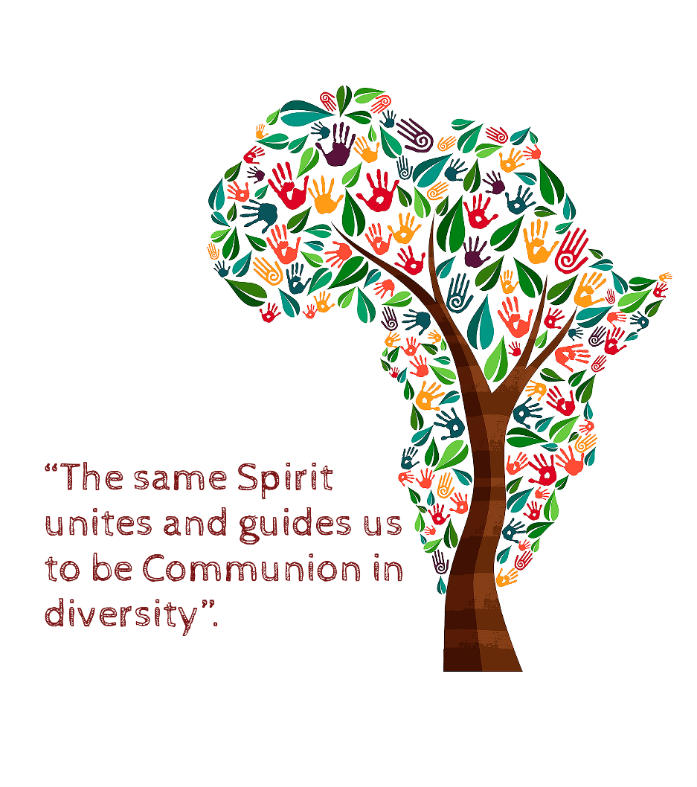
Rooted in Jesus, our center, His spirit, like the sap, nourishes, holds and gives meaning to our faith, to our life of Communion in diversity as an opportunity for service.
He has convened and maintained us firmly united in diversity by the common TRUNK of the Congregational Charism. This holds us and shapes our BEING and DOING, here and now, in the African present, with our gaze placed on the future.
Our fidelity to the inheritance bequeathed by our Founders, keeps it alive (the charism) through the different BRANCHES, the different presences of service.
It (the charism) impulses us to be welcoming, from the hospitality, of the richness and the multicolor diversity that AFRICA offers every day with its people, its culture, its traditions, its music, its dance…
It leads us to make life FLOWER with our HANDS of valiant WOMEN, always ready to give our life up to the point of Heroism by unlearning, getting rid of dry and fallen leaves that takes us away from a rich and leafy life.
Our commitment, united with the collaboration of so many Laity and dedicated people, is an essential FERTILIZER for a fertile land.
Finally, the TREE, proud and leafy, shows its FRUITS:
The poorest, “Our Masters”, receive the tenderness and the mercy of God through our service carried out “with the greatest care, with full detail, with all love”.

